1. Write a function to accept a sentence (that is a line) from the user.

Ans:

#include<stdio.h>

#define MAX 15

Int main()

{

char sent[MAX];

fgets(sent,MAX,stdin);

printf(“string is:%s\n”,sent);

return 0;

}

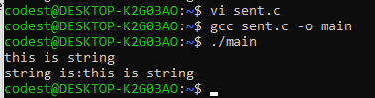

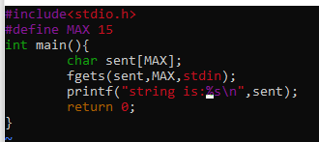

1. Write a function which accepts the sentence and prints one word in a line. A word is a sequence of non-whitespace characters.

#include<stdio.h>

int main()

{

int i;

char s[100];

scanf("%s", s);

for(i=0; s[i]!='\0'; i++)

{

printf("%c", s[i]);

if(s[i]==' ')

{

printf("\n");

}

}

}

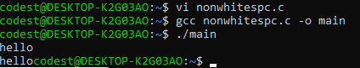

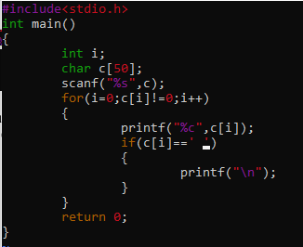

3. Write a function to print the longest word in the sentence (assume all words are of different length).

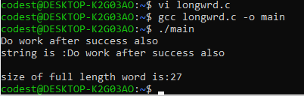

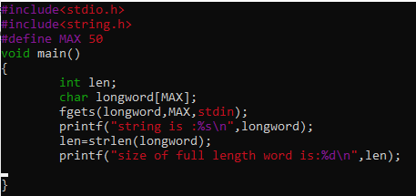

4. Write a function to prompt and read a search sub string, search for the first word containing this substring in input sentence, remove the word and display the sentence after update.

#include <stdio.h>

#include<stdio.h>

#include <string.h>

int main ()

{

char str1[100], str2[100], str_rem[100];

int i = 0, j = 0, k = 0;

printf ("Enter the First string:\n");

gets (str1);

printf ("Enter the Second string:\n");

gets (str2);

for (i = 0; str1[i]!= '\0'; i++)

{

for (j = 0; str2[j] != '\0'; j++)

{

if (str1[i] == str2[j])

{

continue;

}

else

{

str_rem[k] = str2[j];

k ++;

}

}

str_rem[k] = '\0';

strcpy (str2, str_rem);

k = 0;

}

printf ("On removing characters from second string we get: %s\n", str_rem);

return 0;

}

5. Print all words in one line without printing any whitespace

#include<stdio.h>

char *remove_white_spaces(char *str)

{

int i = 0, j = 0;

while (str[i])

{

if (str[i] != ‘ ‘)

str[j++] = str[i];

i++;

}

str[j] = ‘\0’;

return str;

}

int main()

{

char str[50];

printf("\n\t Enter a string : ");

gets(str);

remove_white_spaces(str);

printf(“%s”,str);

return 0;

}